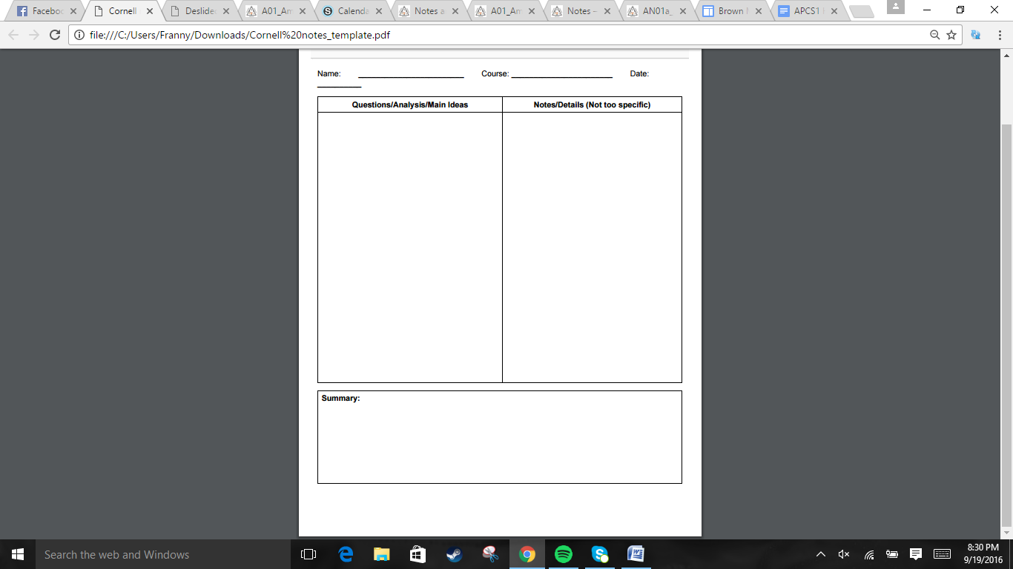  
  
  
  
  
  
  
  
  
  
  
  
  
  
  
  
  
  
  
  
  
  
  
  
  
  
  
  
  
  
  
  
  
  
  
  
  
  
  
  
  


The English made colonies to basically make more money. The colonies smuggled raw materials in an effort to make more money, but then the Navigation Act was passed. The colonies were aggravated even more by King Charles and King James messing with the leadership. The Glorious Revolution happens, which puts the Parliament in power and gives more power to the colonies. As England becomes preoccupied by France in Europe, the colonies gain more room to operate.

.British established colonies under mercantilism (a country's ultimate goal was self sufficiency, and that all countries were competing for the most gold and silver). Britain looked at the colonies as a market to sell goods in and a source of raw materials  
.Mid 1600s, colonists were exporting goods to England, but some were exporting to foreign ports. England viewed this as a lost of money => Parliament passes the Navigation act => English dockworkers, import taxes, and shipbuilding increase in numbers  
.. 1648, England revokes their charter for refusal to obey English laws => royal colony. King James the II succeeded his brother in 1685, made land from Maine to New Jersey into the Dominion of New England. Edmund Andros was assigned to be an officer, only made colonists even angrier by questioning Puritan religion, restricting assemblies, and levying taxes => 1668, Mather sent to get charter back, but the Glorious Revolution happened. William of Orange invited to monarchy to prevent Roman Catholic dynasty, James runs off => Parliament establishes power over monarchy => Massachusetts rebels too => Receives governor of Mas., and non-Puritain representaiton  
.England was busy dealing with France expanding in Europe => salutary neglect from England => Governors had power, but their assemblies determined the gov. pay. => more colonial independence

Jonathan Quang US History 9/25/2016

Section 1: England and Its Colonies:  
How did England and its colonies prosper?  
  
  
  
  
  
  
  
What conflicts arose from this system?  
  
  
  
  
  
  
  
  
  
How does England lose power?

.People grew cash crops to make more money. In the South, plantations developed instead of the towns. Inland, deep, rivers allowed for crops to be shipped directly. The South became largely self-sufficient.  
.Germans, Scots, and the Irish settle in the South. Small farmers formed the majority, but the planters controlled most of the economy.   
.Women were treated as second class citizens => low education, expected to do house work, and to be submissive. Indentured servants were also low on the ladder. Life was bad even after they finished (if they lived). News of the bad experience lowered emigration rates from Europe.  
.Native Americans, indentured servants, were dropping in numbers. => Slavery becomes prominent. Africans become a part of the 17th century Triangular Trade. Voyage for Africans to the West Indies and N America was known as Middle Passage. Poor conditions led to >20% death rate for Africans. Slaves were primarily used for field labor, others for housework or artisanal tasks.  
.Africans brought over their techniques for baskets, pottery, and dance. They also took care of displaced children. Slaves often rebelled=> Stono Rebellion 1739, 20slaves gather weapons, kill families, tried to escape south while gathering more slaves. White militia killed them. Many got away and married Native Americans.

Section 2: The Agricultural South  
  
How did the southern colonies develop a plantation economy?  
How was life in the South?  
  
  
  
  
  
  
  
How was slavery a part of society?  
  
  
  
  
  
  
How did Africans adjust to the new world?

Jonathan Quang US History 9/25/2016

Southern colonies were heavily reliant on farming. As the original source of labor, Native Americans and indentured servants, dwindled, southerners resorted to using slaves. Slaves were treated poorly, on their voyages and at work. They manage to keep their culture and a sense of unity. They often rebelled. Some managed to escape.



.Northern colonies had small farms with a variety of crops and livestock => surplus sent to West Indies => economy also grinded wheat, fished, lumber, shipbuilding, iron mining  
.Philadelphia, NYC, Boston were major cities. Phil, was 1st city since Romans to use a grid pattern. Cities contained police, oil lamps, but lacked firewood, clean water, and garbage collection  
. Immigrants came to escape economic problems, to pursue religious/political ideals,   
.Slavery was less prominent in the North, but racial prejudice still existed. Slaves rebelled once in 1712, causing fear and overreaction.  
.Women were expected to be submissive, had no legal rights, but had many working responsibilities.  
.Witchcraft Trials in Salem, 1692, mass hysteria of a chain of people accusing others of being witches.  
.Enlightenment ideas travelled to the colonies. One example was Benjamin Franklin. Led to natural rights and questioning British Monarchy.  
.New Massachusetts charter of 1691 forced Puritans to allow freedom of worship and to allow non Puritans to vote => more people worried about material possessions => Jonathan Edwards tries to revive the Puritan vision => Other preachers follow => The Great Awakening (1730s-1740s) => Natives and Africans brought into church =>   
The Great Awakening also led to more interest in education and more questioning of traditional authority.

Section 3: The Commercial North

How does growing commerce affect the North?  
  
  
  
  
How is Northern Society Diverse?  
  
  
  
  
  
  
  
What ideas influenced the colonists?

Jonathan Quang US History 9/22/2016

The northern colonies of America relied more on commerce than large plantations. A diverse group of immigrants came to the northern colonies. The European ones assimilated well, but the African slaves had the occasional rebellion. Enlightenment ideas brought to the northern colonies compounded with the Great Awakening led to a higher interest in education and more people questioning authority.



Jonathan Quang US History 9/23/2016

.The French founded Quebec in 1608 => Mississippi Valley claimed for France in 1682 => 1754, New France had grown to ~70k people vs 1 million British. The average French colonists traded furs and wanted to convert Natives. The French were friendlier with Natives.  
. The French and the British both laid claim to land in Ohio. George Washington and his militia was sent to attack the French. Washington ends up surrendering in the battle of May 1754. This marked the start of the French and Indian War.  
.The French and Natives fighting amongst trees was effective against the British orderly rows. 1755-1756 were defeats for the British.  
.William Pitt was appointed by King George II => British army begins winning => Iroquois join them => General James Wolfe surprises Marquis de Moncalm, leading to a victory at Quebec => Treaty of Paris in 1763, East of Mississippi River belongs to Britain, Spain gets New Orleans, and France kept a few small islands. => Pontiac and other Natives attack British forts => British present diseased blankets to Delware chiefs => Weakened Natives sign Proclamation of 1763, which the government failed to enforce  
. The British were allowed to search homes for smuggling, + British sending a standing army to control Natives and French, + 1764 Sugar Act (Half tax on molasses, more tax on other goods, tougher courts) => mad colonists

Section 4: The French and Indian War  
  
How was France a rival for the British?  
  
  
How did the fight between France and Britain happen? /

How did the colonies and Britain grow apart?

The French built a respectable sized colony in northern America that was also friendly with neighbors. However, conflict arises when France and Britain claim land in Ohio. The two war against each other, with France winning the first couple of battles, then the British ultimately winning. British colonies could expand even more, and Britain began to lose its grip on the colonies.